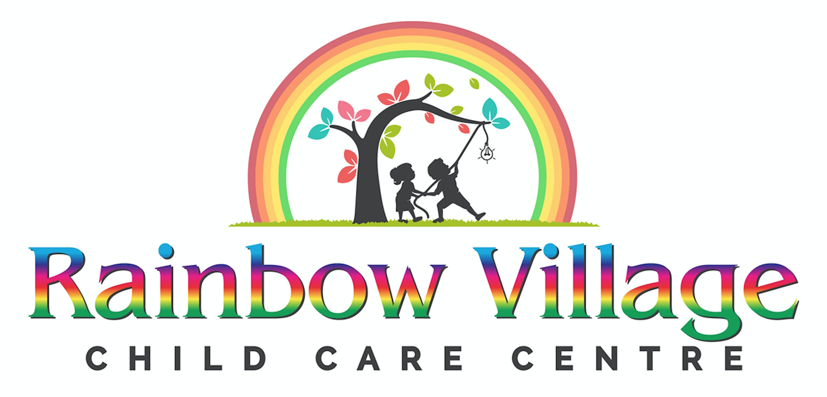
February Newsletter

Winter Gears Reminder
We are off to an exciting new year to continue our journey of learning. With the cold weather season, please have your child dressed appropriately for outdoor play. Just a reminder, to label your child’s winter clothing. Please provide your child with indoor shoes that they are able to fasten and unfasten themselves.

All children are required to play two hours per day; one hour in the morning and one hour in the afternoon.

Valentine's Day Party

On February 14, 2020, Rainbow Village will be having a Valentine's Day Party. You are welcome to dress your child in Red, Pink, or Purple.

Your children will be making special loot bags for their valentine’s cards and treats. Any contributions of cards and treats will be greatly appreciated. However, please be mindful of peanut and nut free only. A list of names for your child's classroom is attached for Valentine's Day card.

Family Day
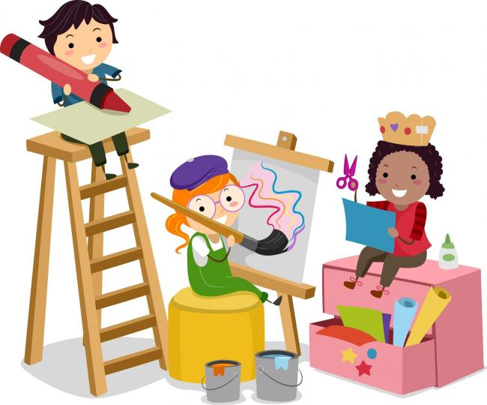
On February 17, 2020 is Family Day, Rainbow Village will be closed.

Cherish your day with loved ones.

